**WEBSITE FOR CODING PRACTISE**

END TERM REPORT

***by***

**MAZIK FERNANDES**

**DEEPIKA CHEKKALA**

**RAKSHITA SONDHIA**

Section: K19RT

Roll numbers: B49, B50, B51



**Department of Intelligent Systems**

**School of Computer Science Engineering**

**Lovely Professional University, Jalandhar**

04-2020

**Student Declaration**

This is to declare that this report has been written by us. No part of the report is copied from other sources. All information included from other sources have been duly acknowledged. We aver that if any part of the report is found to be copied, we are shall take full responsibility for it**.**

Mazik Fernandes

Roll number: 49

Deepika Chekkala

Roll number: 50

Rakshita Sondhia

Roll number: 51

Place: Lovely Professional University

Date: 5/04/2020

**TABLE OF CONTENTS**

**TITLE PAGE NO.**

1. **Background and objectives of project 5**

**1.1 Introduction to coding 5**

**1.2 Motivation for making this project 5**

**1.3 Outcomes of the project 6**

**1.4 Objectives of the project 6**

**1.5 Goal of the project 6**

**2. Description of the project 7**

**2.1 Homepage 7-10**

**2.2 Portfolio page 11**

**2.3 Contact us page 11**

**2.4 Login page 12**

**3. Role and Responsibility 13**

**4. Technologies and Framework 14**

**5. Strengths 14**

**6. Weakness 14**

**7. Opportunities 14**

**8.Threats 15**

**BONAFIDE CERTIFICATE**

Certified that this project report “WEBSITE FOR CODING PRACTISE” is the bonafide work of “Mazik, Rakshita and Deepika” who carried out the project work under my supervision.

Signature of the supervisor

Mrs. Jasleen Kaur

ID of supervisor: 25340

School of Computer Science and Engineering

**1. Background and objectives of the project**

**1.1. Introduction to Coding**.

**Coding** is a skill where you take instructions and translate it into a language the computer understands since computers do not communicate like humans, they communicate in a language called BINARY and it is uses 0's and 1's. Therefore we have a lot of coding websites for people to practice. Coders write the instructions using a programming language. It works as a platform to help programmers make it big in the world of algorithms, computer programming and programming contests. In today's life, there are many coding websites such as Codechef, Codeacademy, edX, Coursera etc.

So this project is basically about designing a web page for coding practice which is done using HTML and CSS. Coding is the basic building block for every computer science engineer. The different coding languages we come across play an important role in the day to day life of a computer student. Just to make it a little easy and try our own coding skills in HTML and CSS, we students have tried our best to design a webpage which basically includes things about how to learn coding and different coding languages. It includes a pattern of questions which people need to try and solve and improve their own coding skills. It contains most of the important coding languages of the world today. We have tried to use our imagination and make it as beautiful as possible.

**1.2. Motivation for making this project.**

The **motivation** for doing this project was primarily an interest in undertaking a challenging project in an interesting area of research. The opportunity to learn about a new area of computing is what we were really looking for. Learning about how to make websites and how they really work has always motivated us to take up this project and give our best to understand about this language and try something different by making our own coding website. Once we started doing it, we realized it’s too much fun to actually know all of this and to implement everything in our own website. Staying motivated essentially means not getting so discouraged that you just give up, we never thought about giving up on this and that’s exactly what made us complete this project today. Our teacher played a major role behind our motivation. She made sure that we understood each and every concept of HTML and CSS which was needed in making this project. She stood like a pillar behind us to help us understand as to how to make it work and she was always there to help us with our doubts.

**1.3. Outcomes of the project**.

The value of any project cannot be measured without defining success. It requires focus on outcomes. Outcomes are the events, occurrences, or changes in conditions, behaviour, or attitudes that indicate progress toward a project's goals. Outcomes are specific, measurable, and meaningful

* It helps student to discover more about coding.
* Teaches new coding languages to the students.
* Improve the students coding skill.
* Clears the concept of each language from the scratch.
* Helps them to take up new coding challenges.

**1.4. Objectives of the project.**

A project objective is a statement that describes the “what” of your project. The “what” that's achievable, realistic, and can be completed within the time allowed. These statements ladder up to the goals of the project, providing stepping stones to success. The main objective of developing this project was to create a static website from which users can get details of the coding website and how they can start learning about coding from our webpage. We made sure that our project is completed on time. The objective was to make our project successful and make other students learn about coding through our website.

**1.5. Goal of the project.**

The project goal refers to achieving a desired outcome (performance goal) at a specific end date (time goal) employing a specific amount of resources (resource goal) This project is in HTML and CSS so it’s a static website and does not perform any type of dynamic database operations. Our goal was:

* To make sure students can understand about different coding languages.
* To work on clearing the concepts of coding.
* To build interest in students while learning through our website.

1. **Description of the project.**

The name of our website is “COMPUTER GEEKS”.

* 1. **HOMEPAGE.**

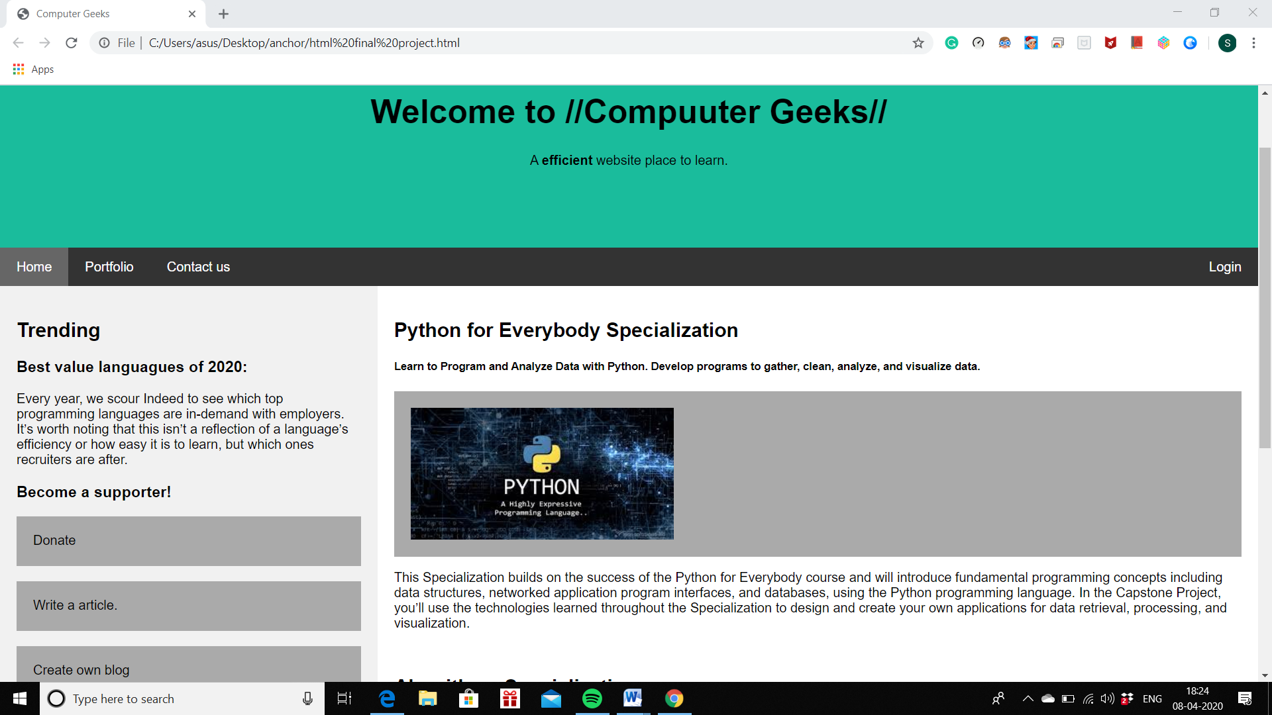

The homepage basically consists of:

* Header
* The navigation bar which includes home, portfolio, contact us and login information.
* The main body which gives a basic idea about the coding page by giving brief introduction about different coding language.
* Footer.

The website start with <!DOCTYPE html> A DOCTYPE declaration appears at the top of a web page before all other elements. According to the HTML specification or standards, every HTML document requires a document type declaration to ensure that the pages are displayed in the way they are intended to be displayed.

The <html> element is the root element of HTML page.

The <head> element contains the meta information about the document.

The <title>element is used to define the title of the webpage as shown in our website as Computer Geeks.

The <body> element contains all the content which is visible in our website.

The <style> element is used to link all the external documents.

The header of the website is made under the <div> tag element. The <div> tag defines a division or a section in an HTML document. The <div> element is often used as a container for other HTML elements to style them with CSS or to perform certain tasks with JavaScript.

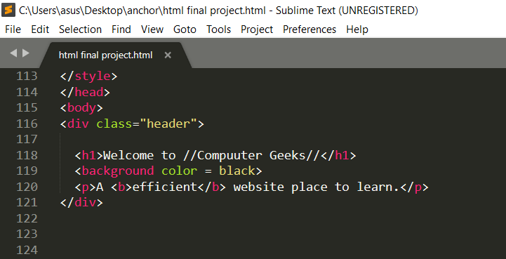

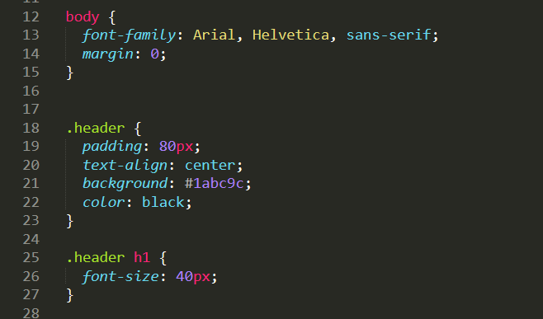

The <a> tag is used to define the hyperlinks used in the website such as Home, Portfolio, Contact Us and Login.

The <h1> tag is used to describe the heading of the page that is “Welcome to //Computer Geeks//”.

The <p> tag is used to write the paragraphs i.e the content which explains the different languages in our home page as well as in the portfolio.

We have also used different type of input tags for the contact information and the login information. We have also used the form tag for the login information of the user.

We have also used the <img src=”> tag to copy the url of the images to be used in the website.

We have used CSS for styling our website and to make it look for impressive. In CSS we have used font-size, font-style, background-color, padding, float, text-align and many more to give style to our website “COMPUTER GEEKS”.

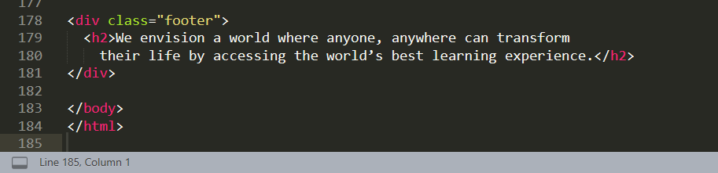

The footer is also made by using the <div> tag and by defining a class to it.

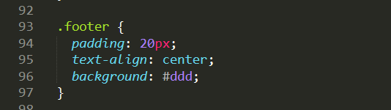

This shows how the footer looks in the homepage.

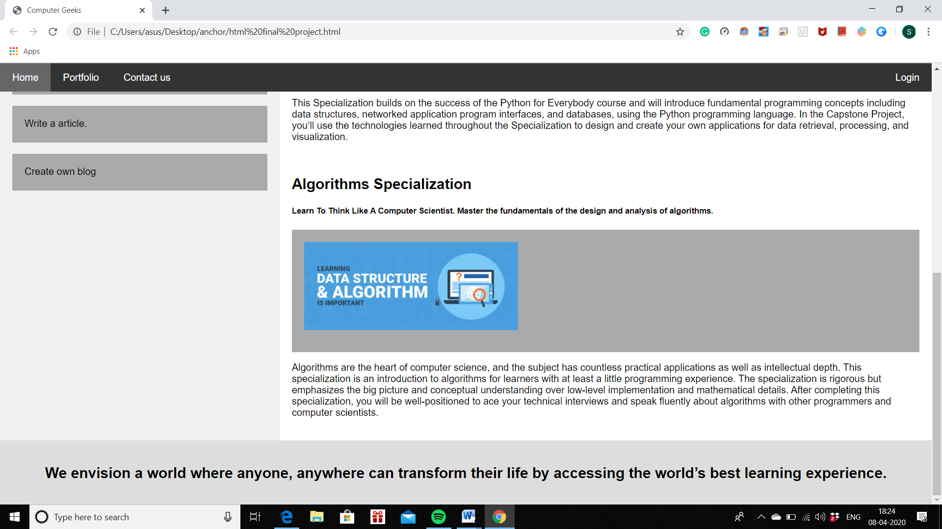

**2.2. PORTFOLIO PAGE.**

We can hover over the portfolio tab and by clicking on it this page will be shown to the users. The portfolio page tells about the other coding languages which are important to know by a coding student. The students can go through our portfolio and give a thought about learning more languages from our website.

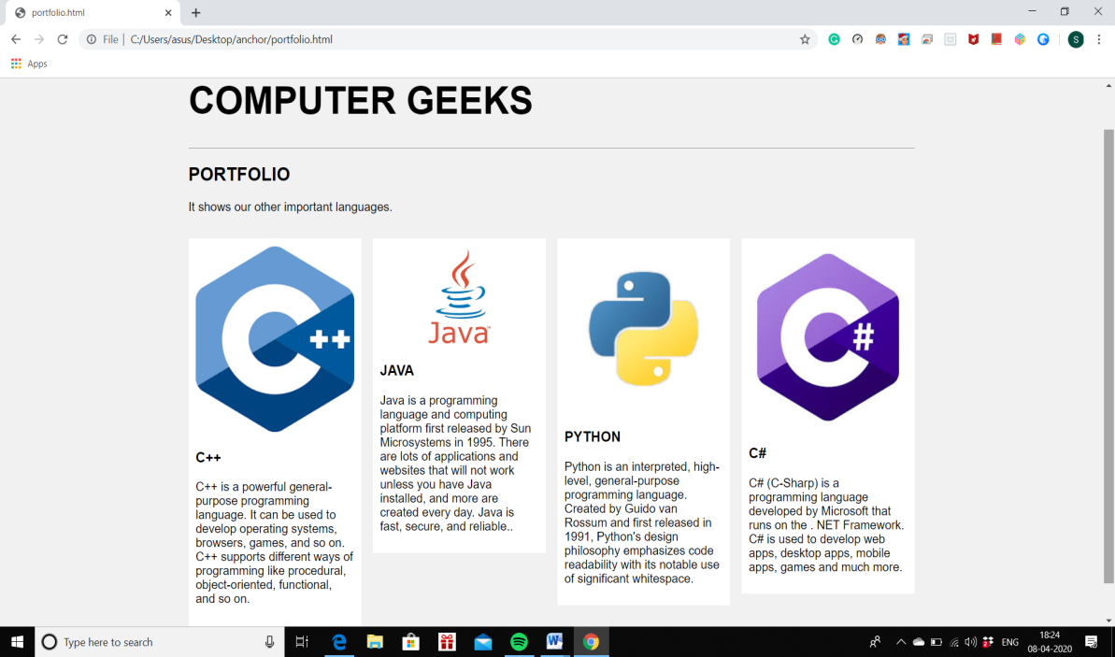

**2.3. CONTACT US PAGE.**

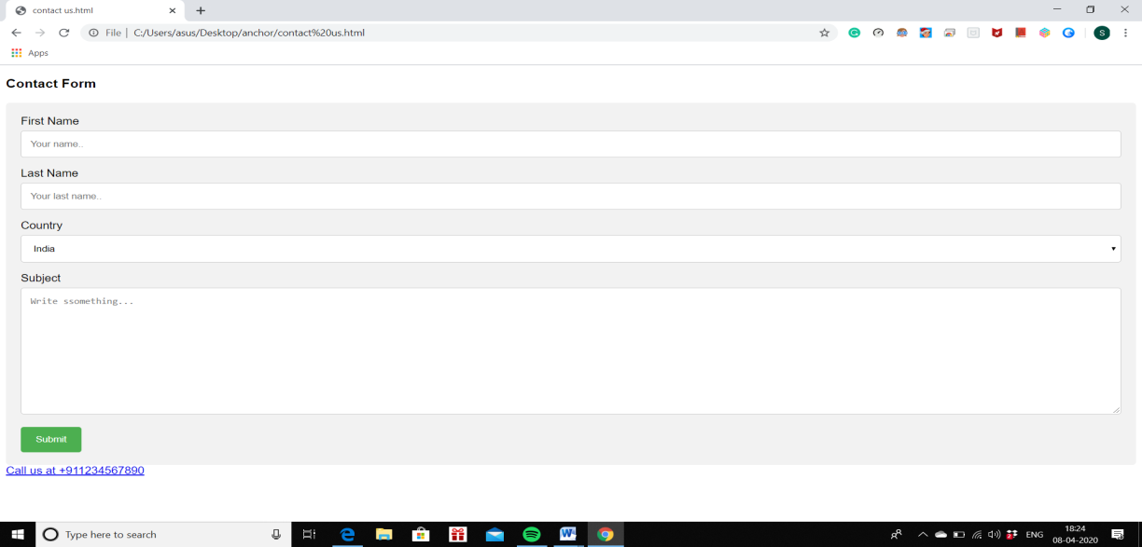

On clicking the Contact Us tab, the users can come across a form which makes them fill their general details like First name, Last name, Country, and about the problems if they are facing them in our website. They can also contact us directly on our official number. This will help us in maintaining regular updates and fix their issues on time.

**2.4. LOGIN PAGE.**

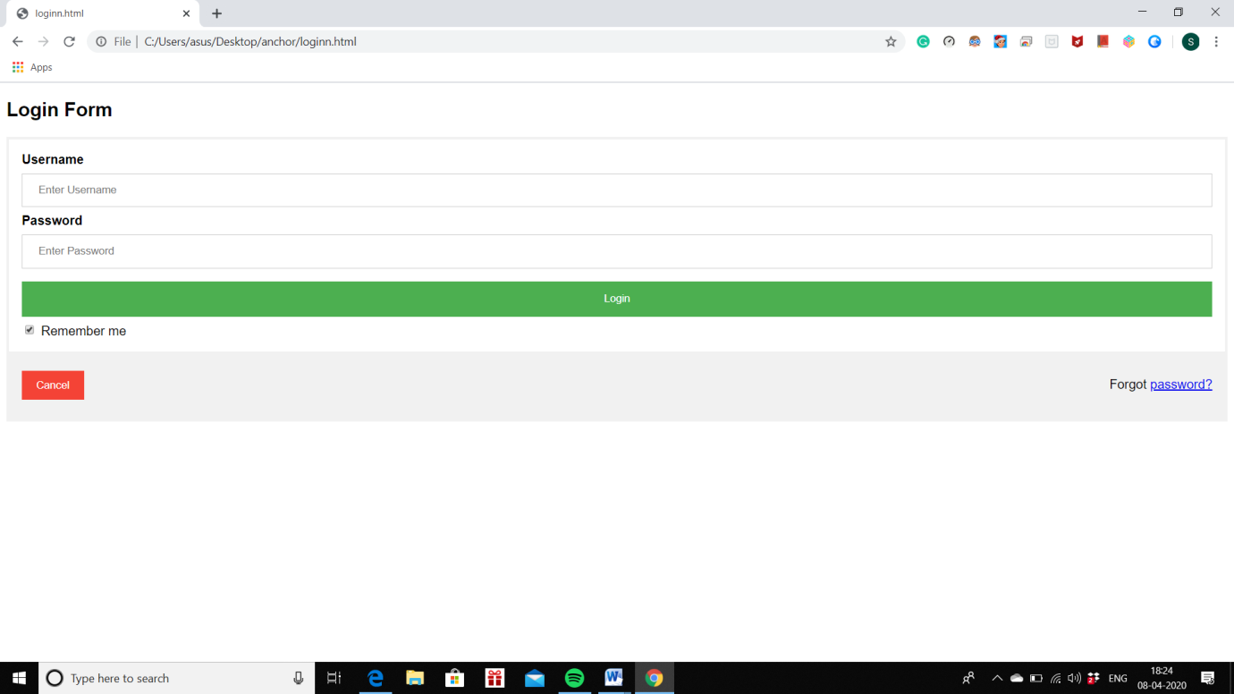

On clicking the login tab, the users can login themselves in our website and learn coding right away. The login information includes their username and their respective password. It also contains an option of forgot password which helps them to recover their password just in case they forget it. It contains a checkbox which is ‘remember me’ to make it easy for them to keep themselves logged in instead of filling their information everytime they want to access our website.

**3.Role and Responsibility.**

* Role of Mazik Fernandes
* Writing the code of CSS part.
* Finding suitable images that support the website.
* Finding the content for few languages used in the website.
* Role of Rakshita Sondhia
* Writing the html code with proper logic.
* Finding the most efficient way to function the working of Website.
* Finding the content for other languages used in the website.
* Role of Deepika Chekkala
* Design and layout of the website.
* Making sure that the website is readable and accessible to all age groups.
* Making video of the website for explanation.

**4. Technologies and Framework.**

We have used HTML(Hypertext Markup Language) and CSS language to complete this project.

We have written the entire code in Sublime Text app.

**5. STRENGTHS.**

* The webpage is supported by all the browsers.
* HTML is easy to use and so is the website.
* Students can learn a lot of things about coding through this website.
* Easily accessible.
* Free of cost.
* It improves the coding skills of students.
* The page is simple to use, it is not complicated for the users.
* It explains the student about the importance of coding.

**6. WEAKNESS.**

* It has less security.
* There is a lot of competition in coding websites.
* People usually go for websites which were made earlier and has more views.

**7. OPPORTUNITIES.**

* Students can take part in various competitive coding programs and win prizes.
* Coding is very essential for a Computer Science Student to get placed in well known private and government companies.
* This website can help students to get ahead in their career and reach one step closer to their goal.
* It is free of cost therefore helping people of lower class to access it too.

**8.THREATS.**

* The website is less secured.
* Can be hacked and misued easily.
* Other people can copy our content for their own websites therefore creating copyright issues.

